6A^{th} Grade: Unit 8, Lesson 5

- Draw the net of the rectangular prism shown.
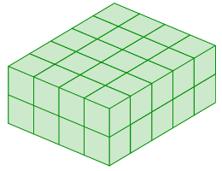
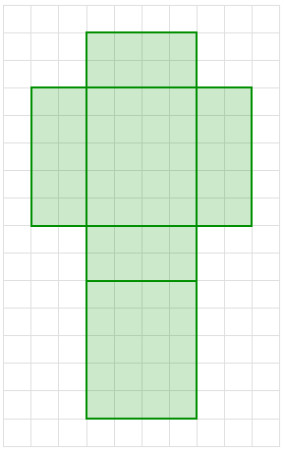

- What is the area of section W in the composite figure?
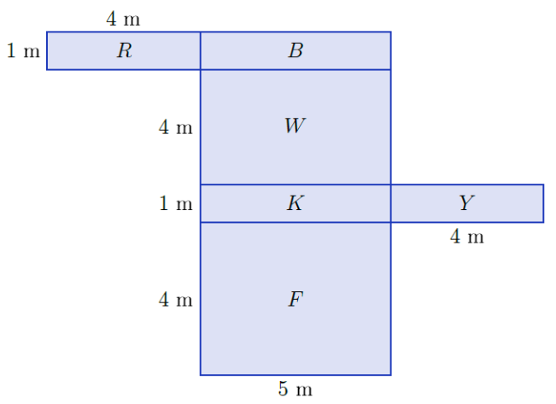
20 m²

- What is the area of section Y?
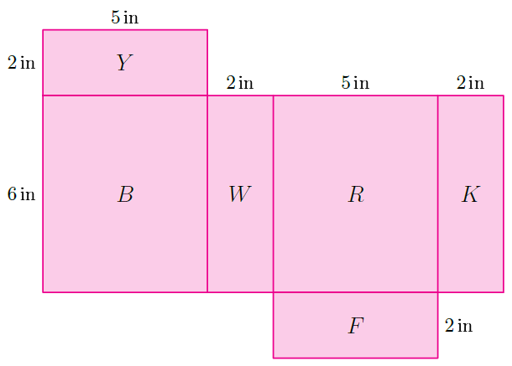
10 in²
- What is the area of the shaded face?
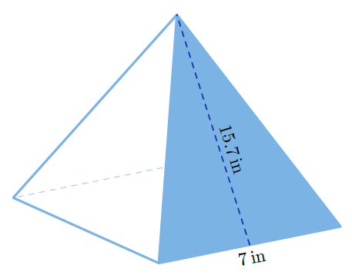
54.95 in²

- What is the area of the triangle?
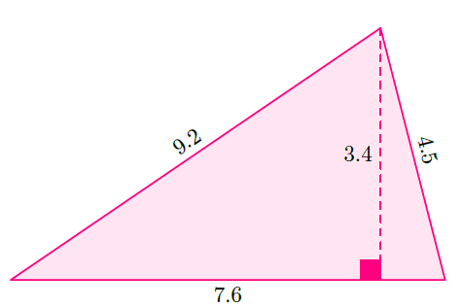
12.92 square units

- What shapes are the different faces of the prism shown?
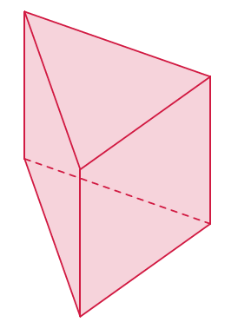
Triangle and Rectangle

